
Build a Use Case -Tokenized Supply Chain Prototype
Objective
Design a basic blockchain prototype where each batch of goods is tokenized as an NFT. This NFT must support immutable lifecycle tracking and transfer of control between supply-chain actors: Farmer, Distributor, Retailer, and Consumer. Include demonstrations of NFT minting, decentralized metadata storage on IPFS, ownership transfers, and recording status updates on the blockchain.

Apparatus/Software Used:
- Solidity (Smart contract language)
- Hardhat (development & testing) or Remix
- OpenZeppelin contracts (ERC-721)
- Hardhat node (local blockchain)
- MetaMask (wallet)

Theory/Concept:

Tokenization links a physical product or batch to a distinct NFT stored on the blockchain. The NFT metadata includes product information and refers to additional documents or media stored on IPFS. Smart contracts manage ownership changes and update the product’s status at each stage. When paired with QR codes, consumers can view the entire history and verify authenticity.

Procedure :
Prepare environment
- Install Node.js along with Hardhat and the OpenZeppelin libraries.
- Launch a local development blockchain using npx hardhat node or use Ganache.
Create contract
- Copy the above TokenizedSupplyChain.sol into contracts/.
Compile & Deploy
- Use Hardhat or Remix to compile.
- Deploy to local node. Save contract address & ABI.
Prepare product metadata
- Create JSON metadata:
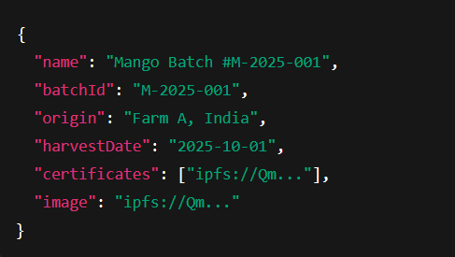
- Upload JSON to IPFS/Pinata → get ipfs://Qm... URI.
Mint token
- Owner (manufacturer) calls mintProduct(to, batchId, ipfsURI, Stage.Manufactured, "Harvested & Packed").
- Note returned tokenId.
Simulate supply chain actions
- Transfer the NFT to the distributor using the ownership transfer function (transferFrom).
- Distributor logs the shipping update: updateStatus(tokenId, Stage.InTransit, "Shipped via Truck").
- Retailer takes ownership and calls updateStatus(tokenId, Stage.ForSale, "Arrived at Warehouse").
- Upon consumer purchase, execute another transferFrom to transfer the token to the end customer.
Verify
- Call getHistoryCount and getHistoryEntry to view events.
- Scan QR code (links to token metadata page) → show IPFS metadata + chain history.

Observation table:
